**7th Week Report**



**OJO Members:**

Abdullah Aslam: ***phone:*** *+90 (538) 050 37 64* ***email:*** *ama.abdullah90@gmail.com*

Anar Abdullayev: ***phone:*** *+90 (553) 924 96 43* ***email:*** *abdullayev.1995@gmail.com*

Bulut Ulukapı:  ***phone:*** *+90 (555) 367 26 16*  ***email:*** *ulukapi.bulut@metu.edu.tr*

Syed Saad Saif: ***phone:*** *+90 (546) 781 99 50* ***email:*** *saad.saif@metu.edu.tr*

Umut Can Serçe:***phone*:** *+90 (506) 997 99 88* ***email:*** *serce.umut@metu.edu.tr*

This week we continued our work on designing the holders, implementing the algorithm for the overall behaviour of the robot and also implementing some holders and circuits on the robot physically.

**Holders**

We continued designing new holders for our robot on CAD. This week we designed holders for the lasers and ultrasonic sensors on the both sides of the robot. A 3D drawing is provided at the end of the report(*Figure 1.*). Ultrasonic sensor will be placed in the middle and laser will be placed in one of the small holes on the sides on *Figure 1.*

**Solar Panel Circuits**

We soldered the already designed solar panel circuits to the protoboard and then placed them on sensor holders. To minimize the outside lighting condition effects as much as possible we isolated the solar panels with electrical tape and applied some tests on the circuit before and after placing it on the holder. After getting the successful results we designed a new piece on CAD accordingly for a better and neat implementation. Moreover we decided to conduct some test with a thin piece of paper to filter the laser light as soon as possible.

**Robot Maneuvers**

After implementing the lateral exit part of the leaving maneuver successfully, this week we continued our algorithm for the solar sensors. This is necessary for the robot to understand that it is the last one before rejoining the convoy and update the last one flag. Hence we created a flag library for that purpose. Also we improved our main controller library and added some new functions.

**Testing Solar Panels with New Library**

After completing the physical implementation of solar panels and creating the related library with synchronization in a parallel workload we immediately tested both. We connected both solar panels to Arduino and our algorithm could detect the laser and its direction such as if it is from the right solar panel or the left one.

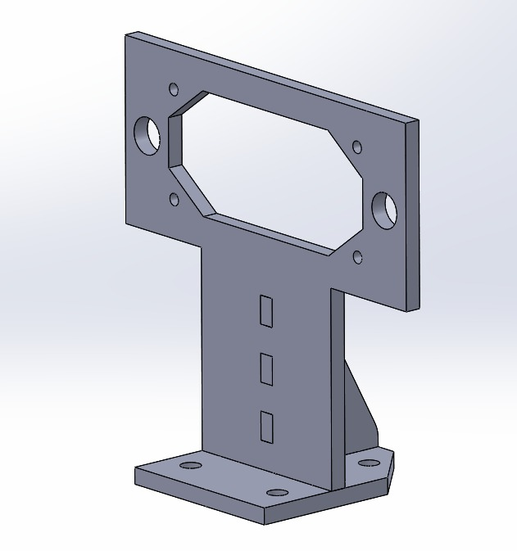

Figure 1. Sensor Holder